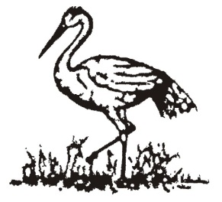
CRANLEIGH & SOUTH EASTERN AGRICULTURAL SOCIETY

RESULTS

JUDGING DATE: 18TH JANUARY 2012:

Class 15: BALED SILAGE – The Biotal Perpetual Challenge Trophy
Class 16: HAYLAGE - The Gerald Shearing (Livestock Supplies) Perpetual Challenge Trophy
Class 17: SILAGE CLAMP – GRASS - The Five Oaks Perpetual Challenge Cup
(Kindly Sponsored by C&P Roe (Liming), Devon)
Class 18: SILAGE CLAMP – MAIZE
(Kindly Sponsored by Agricultural Central Trading Ltd, Bucks)

CLASS | 1ST | 2ND | 3RD
15 | Lukyns Estate, Ewhurst | Feltons Farm, Brockham | PJ Coles, Frys Cross Farm, Dunsfold
16 | Five Oaks Farm, Billingshurst | Upper Ifold Farm, Dunsfold | Lukyns Estate, Ewhurst
17 | GLB Foulger & Son, Drungewick Hill Farm, Loxwood | Westnedge & Knight, Hathersham Farm | Ruckmans Ltd, Dawes Farm, Warnham
18 | Westnedge & Knight, Hathersham Farm | Westnedge & Knight, Norwood Place Farm | Hill House Farm, Ellens Green

